1. Link github :

<https://github.com/hadi-web/Web-Programming-II>

1. Source Code

* Controller 🡪 Perkenalan.php

1. 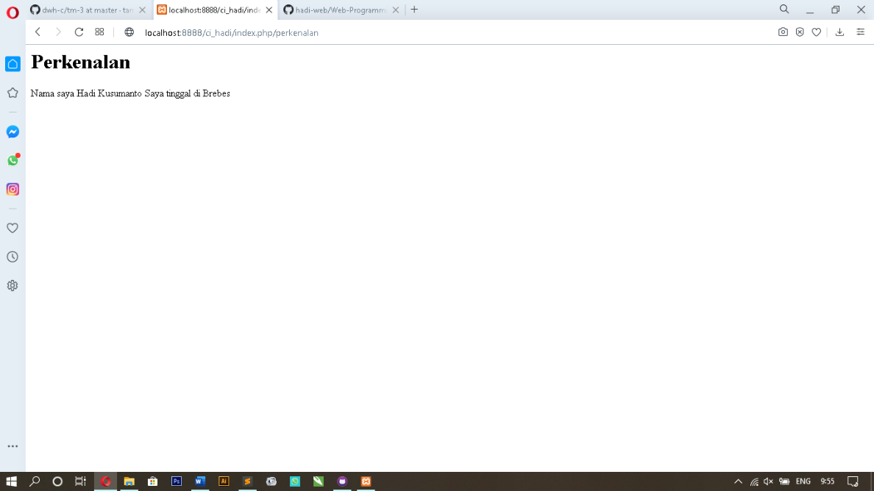Screen Shoot